**Step 1**

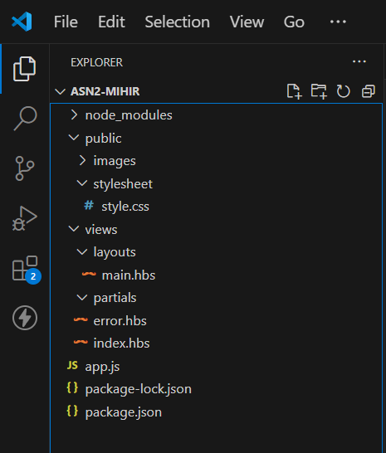

**Step 2 copied all codes from the given text file to respective files.**

**Step 3**

<http://localhost:3000/>

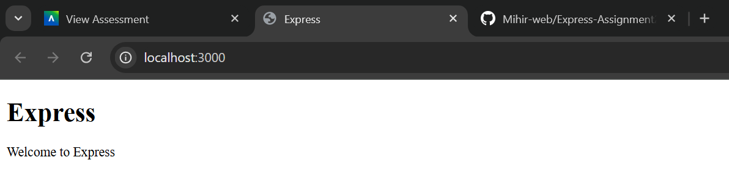

<http://localhost:3000/users>

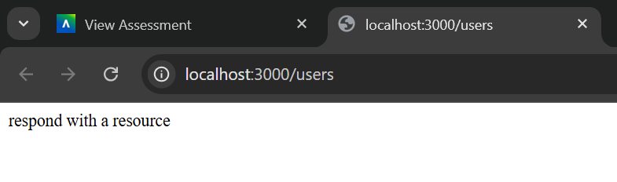

<http://localhost:3000/notExist>

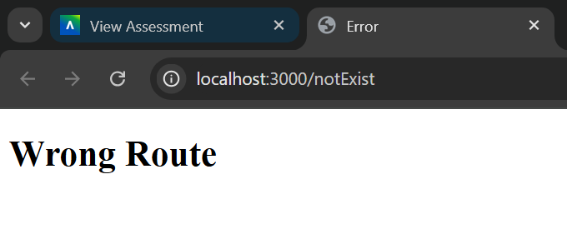

**Step 4**

a). What is the role of “main.hbs”? How does it being used/called in the app?

Answer: main.hbs file serves as its core layout file, establishing common elements and adding targeted content such as CSS and Js we will be using throughout all web pages. So to maintain a consistent and well-organized structure of website, main.hbs file plays vital role.

b). What is the role of “index.hbs” and “error.hbs”? How do these files being used/called in  
the app?

Answer: index.hbs file is responsible for rendering the home page content when the user visits the root URL. The error.hbs file is responsible for rendering error messages in case the user enter the wrong route.

c). n “app.js”, what is the role of the following line? What happen if you commend it out?

Answer: In the given code we are just setting the root paths for static content such as images, CSS, and js so later on whenever we want, we can call CSS by writing path ‘/stylesheet/style.css’

d). Try to add proper comments to each line/block in app.js

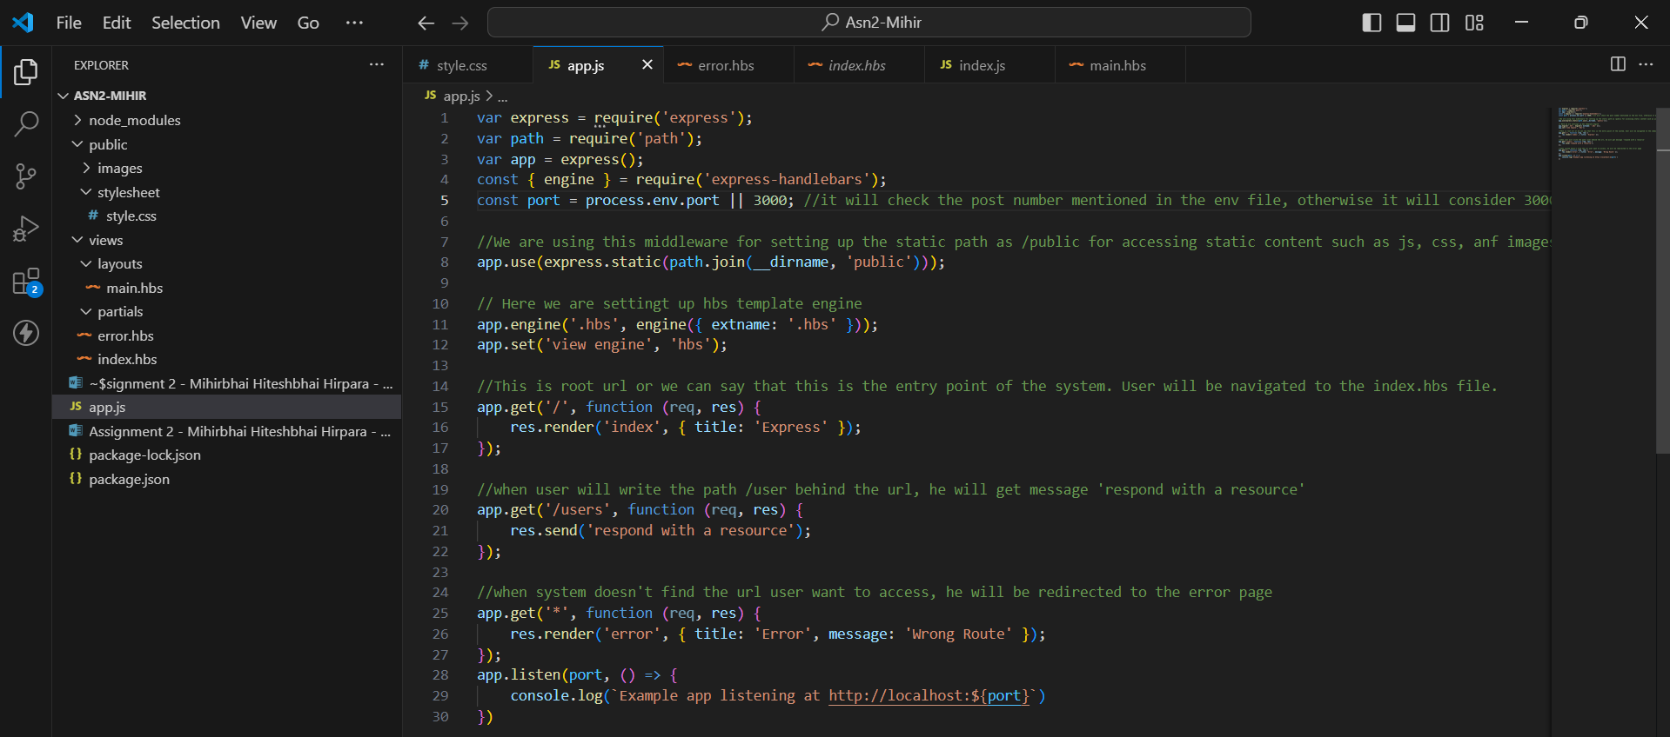

**Step 5**

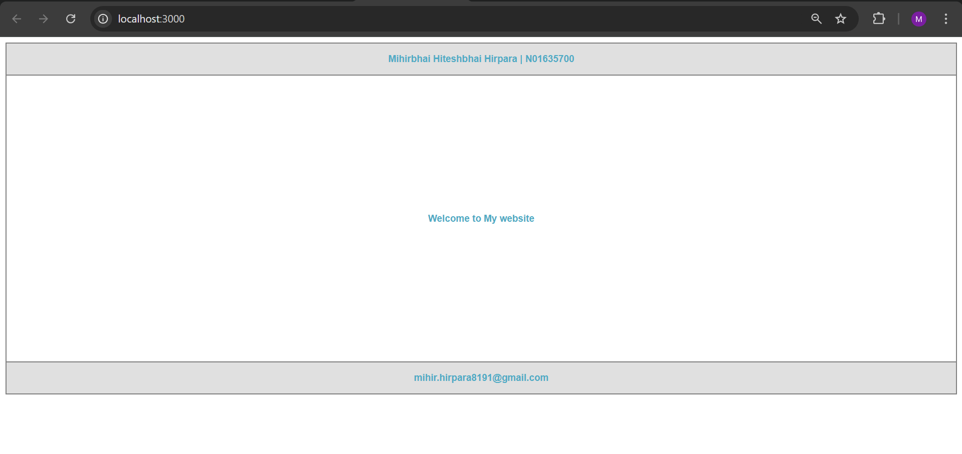

**Step 6**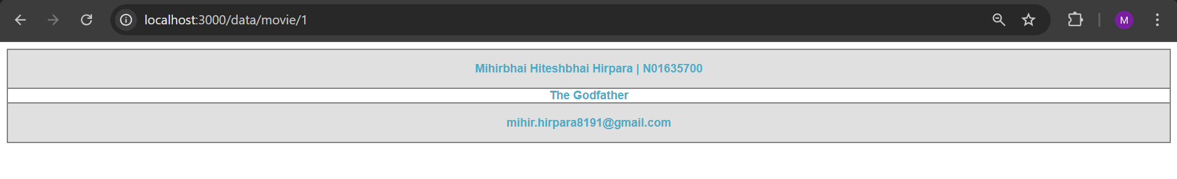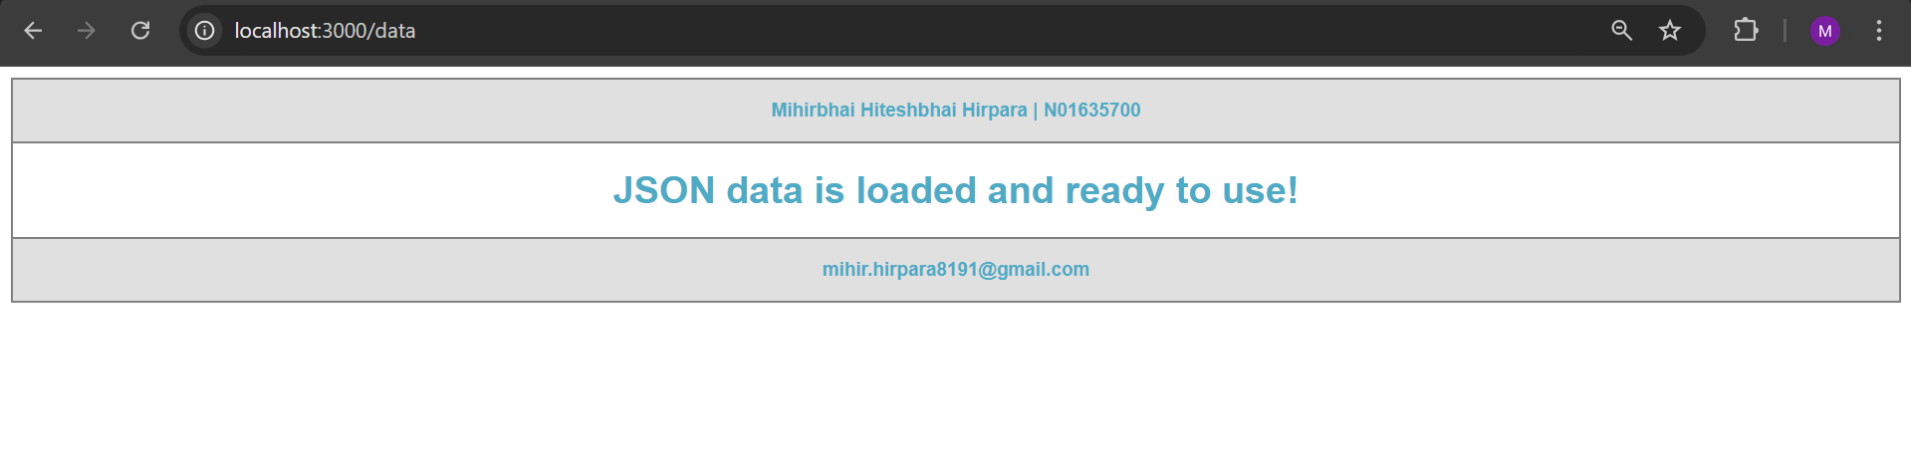

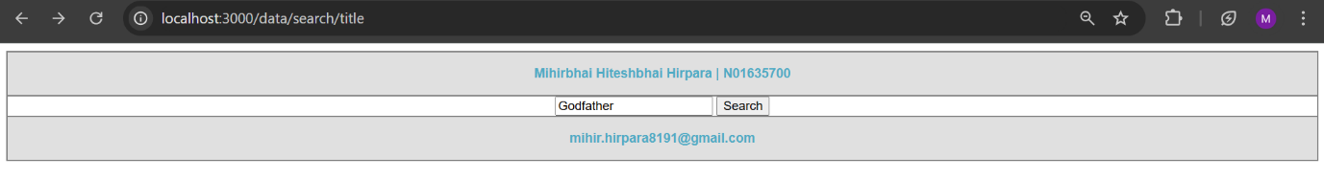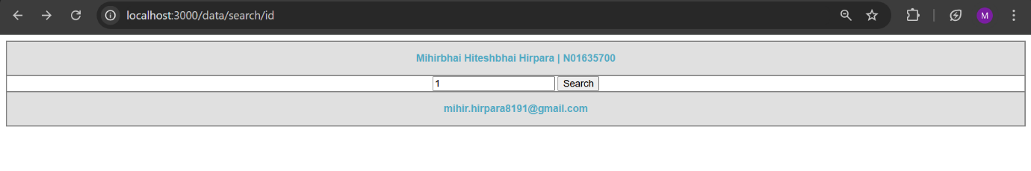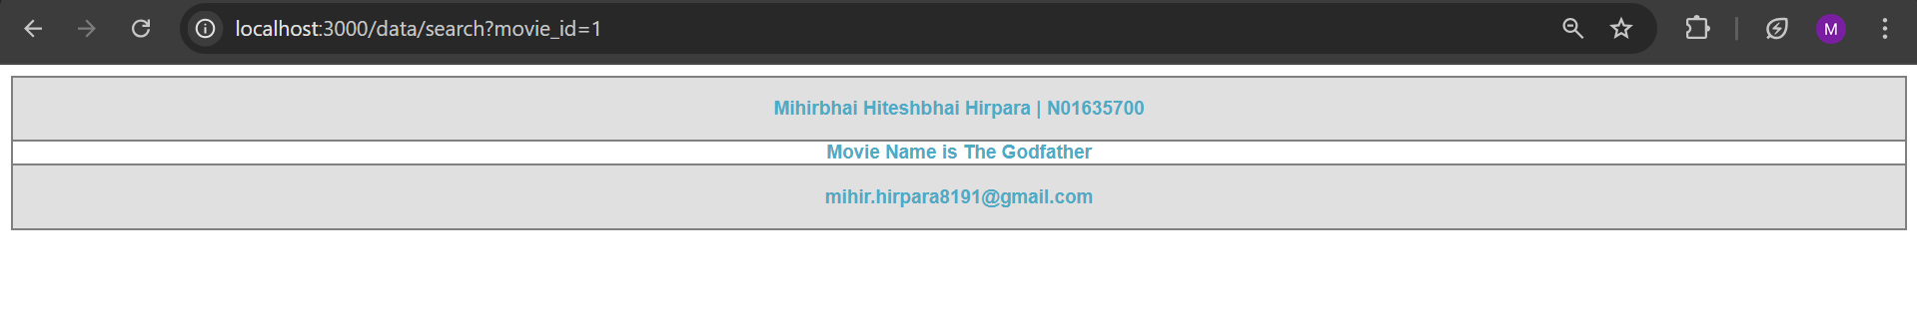

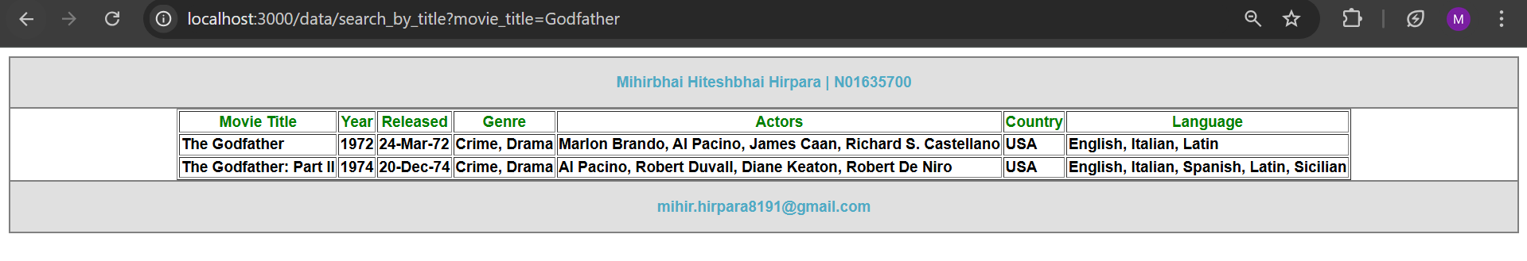

**Step 7 /allData**

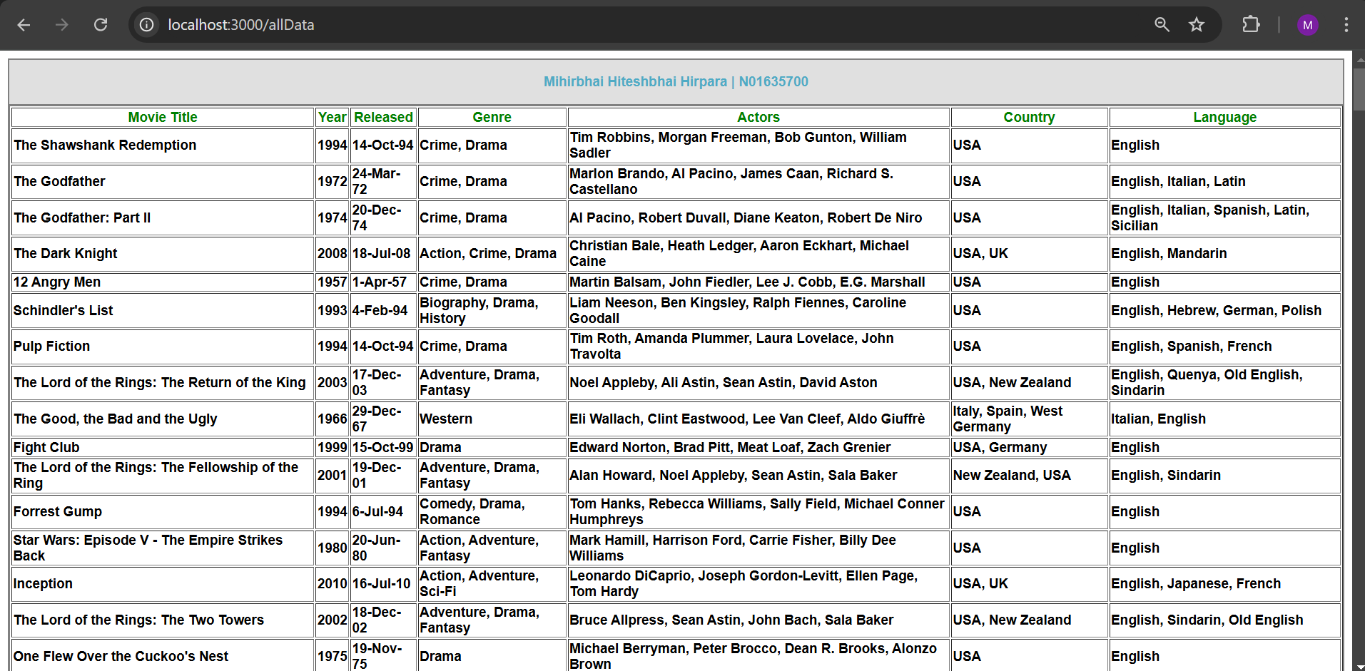

**Step 8 (Removed all row which has null Metascore)**

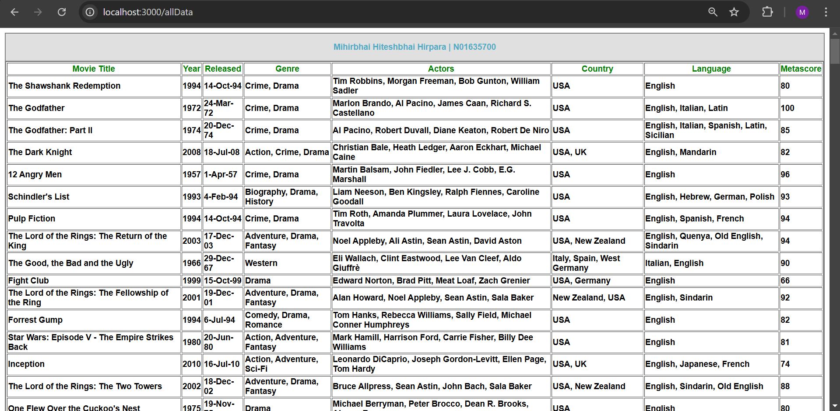

**Step 9 (highlighted all rows which has Metascore N/A)**

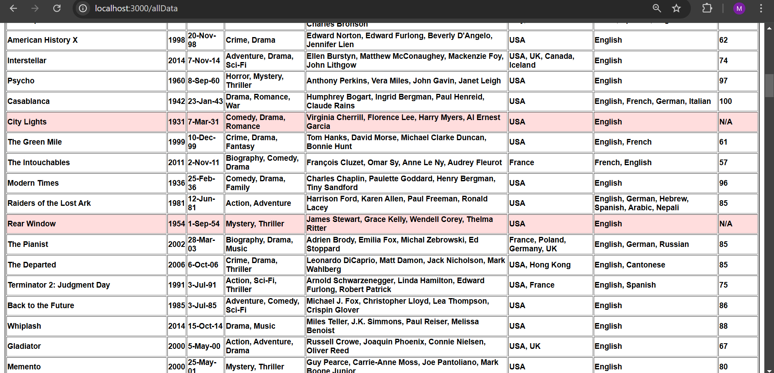

**Step 10 (I considered header and footer as a partial templates)**

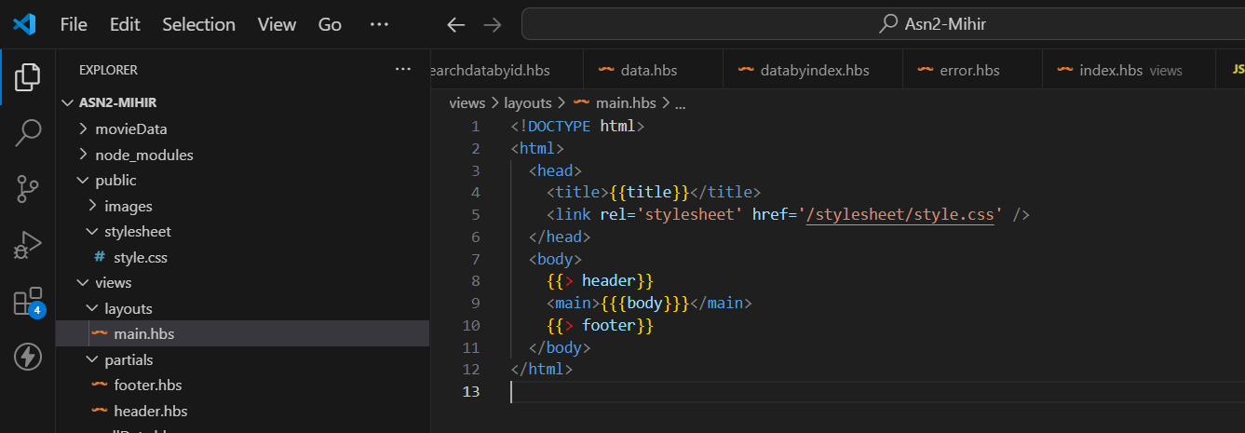

**Step 11**

**Live Site Link:** <https://asn2-mihir.vercel.app/>

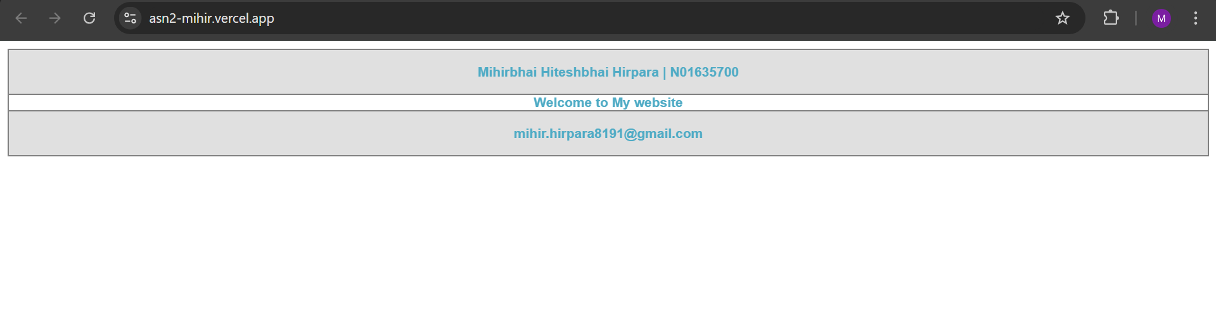

**Step 12**

There are two well liked Node.js template engines, Handlebars and Pug, each with unique characteristics. Pug is renowned for its simple syntax, which eliminates code clutter and makes templates appear cleaner by employing indentation rather than closing tags. Additionally, it allows JavaScript inline, which enables more dynamic logic to be used directly in templates. For intricate patterns, this could make templates more difficult to read. In contrast, handlebars employ syntax similar to HTML, which web professionals are accustomed to. Its emphasis on readability and simplicity facilitates maintenance and debugging, particularly for bigger applications. Handlebars lacks Pug's inline JavaScript flexibility but has a strong helper system that improves functionality.